Treaty of Versailles Role Play

- Look at the different options in chart 1 based on the different areas of concern
- Research which options the leader of your delegation or country (French, English, American and German + Italy + Japan)
- Once you’ve decided on what your leader would have wanted - come together with the other leaders and try to negotiate a final Treaty
- Together we will review the chart and look at what actually happened

http://www.johndclare.net/peace_treaties3.htm

Options
Area of Concern | Option 1 | Option 2 | Option 3 | Option 4
Blame - Who is to blame for the war | Germany | No one nation can be blamed
Reparations: Cost of the War  Germany must pay - but how much | £2,000,000,000 | £6,600,000,000 | £24,000,000,000
Germany Military | Reduced to 100,000 men. German Navy reduced to 36 ships. No conscription allowed. No tanks, submarines, or aircraft to be built. All wartime weapons to be melted down. | Reduced to 250,000 men. German Navy reduced to 50 ships. No conscription allowed. Allowed to keep all tanks, submarines, and air force. | No further conscription, though forces to remain as before the war - 1,000,000. All armed services to be at prewar levels.
Colonies  These were mainly in Africa such as Togoland and Tanganyika, plus lands captured from the Turks | The colonies are to be allowed to govern themselves as independent nations. | France and Great Britain split the colonies and territories captured from Germany and Turkey | The colonies are put under the control of the League of Nations until further decisions are made as to who is to run them. | They should be given to Japan and Italy in exchange for help during the war
LANDS: Rhineland  The area that lies on the German side of the border with France | The Allies take control of the area not allowing the German military to have a presence in the area. | The League of Nations occupies the area so no one nation has it under control. | Allow the Germans some control of the area with Allied supervision under the control of the League of Nations.
Alsace-Lorraine  Once part of France, it was taken by the Germans in 1870. | Returned to France | Germany allowed to keep it. | Placed under the control of the League of Nations until a decision is made.
Saar  An area of Germany with excellent coal fields. | Give to France for 15 years. The French need the coal mines to rebuild after war. Following this time the people of Saar vote to see if they want to be French or German | Remain in Germany - the rich coalfields are needed to build the Germany economy after war. | Let Germany keep it - but half of any profit from the field must be given to the allies as war damages.
Poland | Let it remain in German hands | Make it a protectorate under the League of Nations until a vote can see who should govern it | Become an independent nation - this will cut off east Prussia (Germany) from the rest of Germany. It will have a port to trade with.
Danzig  A city of both German and Polish people | Let the Germans keep it | Let the Polish have it | Make a free city
League of Nations | Forget it, we don’t want our country to bow to a foreign council who can decide our actions | We’ll join if we get many of the other terms we want | We will join as a full member in order to help prevent future conflicts as a large world council
Should Germany get to join the League of Nations | No | If they get a harsh treaty | Yes they should be allowed to play a roll in peacekeeping
Should a racial equality clause be added to the league of nations constitution? | Yes but Japan can’t be considered a great power | Yes and they should be added to the list of great powers and given major rights | NO, excluded because of racial discrimination

Your individual leader’s choices (America, France, England, Germany, Japan, Italy)
Area of Concern | Result - please write in your result (also include comments on your decision)
 | Option | Reason
Blame - Who is to blame for the war?
Cost of the War - How much should Germany pay?
German Military

Colonies - These were mainly in Africa such as Togoland and Tanganyika, plus lands captured from the Turks. |  | .
Rhineland - The area that lies on the German side of the border with France |  | .
Alsace-Lorraine - Once part of France it was taken by the Germans in 1870 |  | .
Saar - an area of Germany with excellent coal fields |  | .
Poland  . |  | .
Danzig - a city of both German and Polish people |  | .
League of Nations
Should Germany get to join the League of Nations
Should a racial equality clause be added to the league of nations constitution?

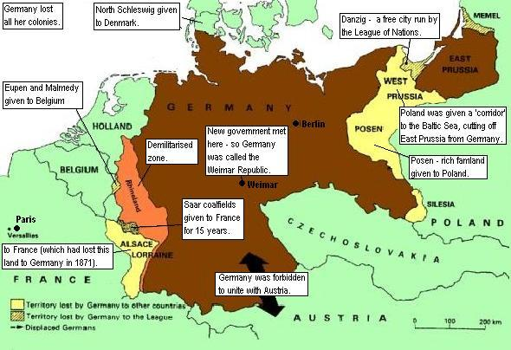

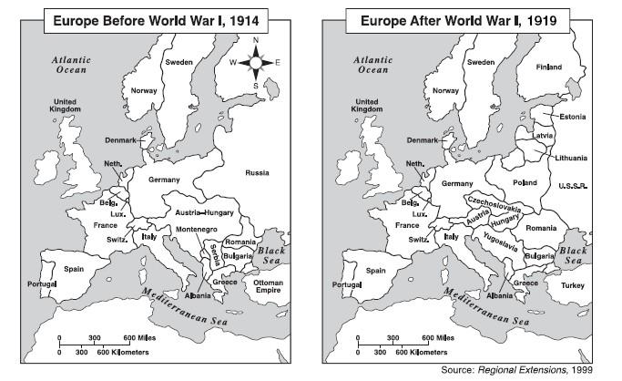

Format of Debate
1 | Opening statement by each country 2 min each
2 | 30-45 seconds of discussion on each issue by each party
3 | 10 min free negotiation time
4 | Vote on each and one sentence why (options 1, 2 , 3 or original)
Everyone must speak

Final vote
Issue | America | Britain | France | Italy | Japan | Germans | Final:
Blame - Who is to blame for the war
Reparations: Cost of the War
Germany must pay - but how much
Germany Military
Colonies
These were mainly in Africa such as Togoland and Tanganyika, plus lands captured from the Turks
Rhineland
The area that lies on the German side of the border with France

Alsace-Lorraine
Once part of France, it was taken by the Germans in 1870.
Saar
An area of Germany with excellent coal fields.
Poland
Danzig
A city of both German and Polish people
League of Nations
Should Germany get to join the League of Nations
Should a racial equality clause be added to the league of nations constitution?

