The Business

1a. Basic business details
Cartoony Solar Toy Carz Ltd.
Based in 19 Shum Wan Road, Aberdeen, Hong Kong. Phone: 852-2345-6789
Factory located Mao Ze Dong Factory Place, Leiho, Guangdong. Phone: 321-012-345-7890
Our products will sold at various toy and stationary shops around Hong Kong and Mainland China
Makes Solar Toy Carz with pictures of characters from cartoon shows

1b. Partners
- Jeremy Lau 50%
- Justin Chan 25%
- Anson Leung 15%
- Gabriel Tsang 5%
- Michael Budihardjo 5%

Cartoony Solar Carz Ltd. is a small company based in Hong Kong. The founder is Jeremy Lau from Victoria Shanghai Academy and it uses the partner system to operate. There are five partners altogether, me being the biggest one. Justin Chan is the second biggest and he owns a quarter of the company while Anson Leung owns 15%. Gabriel Tsang and Michael Budihardjo each own 5% of the company.

1c. Aims and Objectives
- To be the leading solar toy car maker in Hong Kong by 2015
- To be able to build solar cars that can be controlled through remote and also to build solar cars that can turn by themselves using cameras and to start selling them by 2015
- To have 500,000 units sold to customers by 2015
- To be known as a reliable and good producer of solar toy cars
- To sell 20 kinds of cars, 1 kind of car is for 1 cartoon programme.
- To start selling other types of toys other than cars that is to be powered by solar energy
- To have our toy cars sold at Toys’R’us 2-3 years after the start of the company
- To have our toy cars sold at over 10 shops after 10 months of starting the company

As you can see, my company Cartoony Solar Toy Carz Ltd. is a small company with high hopes. As founder, most of my targets are currently set on the year 2015. We hope to have a stable and bigger business by 2015 and by doing that we will have to hire more workers and build bigger factories as our company expands.
The Business Idea

2a. Details of Product and Competitors
We create solar toy cars in different shapes and sizes in different color with a cartoon character on it. I aim to create each car to be almost indestructible, because the target is ages between 3-10, but that will drive the cost up. I also want people to recognize my car easily so I will make sure that the colors stand out and that there is a unique design. Also, I would like each carton show to have its own unique color, e.g. yellow cars all have pictures of Spongebob Squarepants, and no yellow car will have pictures of any other cartoon characters that don’t appear in Spongebob Squarepants.

To promote my business, I will offer free membership to the Cartoony Solar Toy Carz Club to anyone who buys at least two of my cars. To do that, buyers will go on to the company website and enter the code from the manual, entering two will give you full membership and there will be discounts and promotions on the website. The website will also have games that educate children on the importance of solar energy and saving the environment.

There are cars that copy modern day cars like Ferraris and Lamborghinis which will appeal more to the older children aged between 7-14 which could harm my business. Also, there are big toy companies working on solar powered toy cars which could also harm a big bit of my business because they are better known, more popular, and trusted. To solve these problems to expand my business, I will have to make sure that my company is always one step ahead of theirs, and build better and cheaper cars than theirs or I won’t stand a lot of chance. Also, to be able to sell our cars with the pictures of cartoon characters legally, we will have to get the copyright first. Some companies may not allow us to do so but we will have to fight hard and maybe even offer up to 50% of profits for them to allow us to use their cartoons. However, I will never make cars that are without cartoons because I think that it is really important because the kids these days watch TV at a young age and they will recognize and like certain cartoon characters a lot. Also, the cartoon characters on our cars are what makes my companies product different from the other companies.

2b. Unique Selling Points
- All our products will be made by robots that are operated by the workers to make sure that we will make a lot of cars. All products will be tested before selling it. All products must work and run smoothly and be of good quality
- The products will look really good and is durable because it is to be played by young children
- The products will be very clean and safe to use, there aren’t any sharp edges and it is even waterproof.
- It comes with a manual that will educate students and young children to recycle more and use more solar energy
- The motor will be made of stainless steel to make sure that the car lasts long and doesn’t rust

Management and Personnel

3a. Key Personnel
The person who will run the company is me from Victoria Shanghai Academy in Hong Kong.
Jeremy Lau, 13, CEO/Owner

3b. Workforce
We will employ 10 employees, here are the list of employees, what they do, their qualifications, where they work, and how much they will get paid:

- Cole Lam,
Bachelor of Arts (Economics Studies)
Sells our toys to the stores in Hong Kong and gets them to sell it
In Hong Kong
$25,000/ month

- Alex Ching,
Master of Engineering,
He tests cars and thinks of ways to improve them.
In Guangdong
$30,000/ month

3. Michael Budihardjo,
Gets 7 in Technology every single time
He makes the cars
In Guangdong
$15,000/ month

4. Gabriel Tsang, Gets 7 in Technology every single time
He makes the cars
In Guangdong
$15,000/ month

5. Anson Leung, Gets 7 in Technology every single time
He makes the cars
In Guangdong
$15,000/ month

6. Ernest Ching Gets 7 in Technology every single time
He makes the cars
In Guangdong
$15,000/ month

7. Malcolm Wong Gets 7 in Technology every single time
He makes the cars
In Guangdong
$15,000/ month

8. IP, Kwai Wah
Gets 7 in Technology every single time
He makes the cars
In Guangdong
$15,000/ month

9. Justin Chan Master in Business Administration
He is in charge of the factory
In Guangdong
$30,000/ month

10. Matthew Wong
Master in Business Administration
He is my advisor
In Hong Kong
$30,000/ month

Marketing Plan

4a Market analysis
The target market for my solar toy cars are boys and girls aged between 3-10. I came to the conclusion because I think that in Hong Kong, children are already exposed to cartoon shows by the age of 3 and start to stop watching or show little interest in cartoon shows at around the age of 10. So far, there are not any other famous or well known toy car makers that put cartoon characters on their cars and operate on solar energy so there is little competition from other companies in that area, but some kids may still choose other solar toy cars that don’t look as good. Also, I think that if many people start buying them, it can be a collector’s item and people would want to show off some of their cars, e.g. everyone wants to buy a car from each cartoon. If that happens, then I think that the company would make a lot of money and the company could expand and build more toys.

Although solar toy cars are things that have just appeared in the market, there is still a lot of competition around. There are many scientific companies that make solar toy cars just for educational purposes and they would sell these to schools at a really low price. However, I am unable to do this because I don’t think that schools will accept cars with cartoons on it. Also, there are solar toy cars which are models of sports cars which are popular with young boys. However, my car appeals to boys and girls of ages 3-10 so there is a big target market.

4b SWOT analysis
Strengths
- It is unique as a solar toy car maker with cartoons
- It looks better than other cars
- It is really durable
- It is good for the environment and educates people on the importance on saving the environment
- It is of very good quality

Weaknesses
- It is heavier and slower than other
- It costs more because of the cartoon copyright
- It uses more energy than regular solar toy cars

Opportunities
- People prefer things that save energy
- It looks better and is more durable than other solar toy cars
- It is bigger and can hold more decorations and things

Threats
- People that aren’t in the target group will not buy the cars because it doesn’t appeal to them
- People would want to save money on products and my car is more expensive than theirs
- Other toy cars are faster and lighter than mines
- Some toy cars are remote controlled while mines isn’t

The Production Plan
The cars will be assembled in a factory in Guangdong, China. They will be made by robots and be of the highest quality.

Steps | Time required | Materials | Equipment | Quality Check | Safety Concern
Cut out the pieces of acrylic plastic using templates | 30 min | Acrylic plastic | Templates,  Laser cutter | See that it matches the templates and the sides are smooth | You could cut yourself with the cutter
Attach the wheels to the car | 20 min | Wheels, straw, rod | Hot glue gun, hammer | See that the wheels are parallel to each other and that they run smoothly | You could burn yourself
Attach the motor to the bottom | 20 min | Motor, screws | Screwdriver  Hot Glue Gun | See that the motor is attached securely | You could burn yourself
Attach the battery case to the motor | 20 min | Battery case, battery, cables | Hot glue gun, scissors | Check if the motor and battery case is working by having a test run | You could burn or cut yourself
Attach the other pieces to the bottom piece to complete the body of the car | 45 min | Acrylic plastic | Hot Glue Gun | See if it matches the design and templates. Also see that it is rigid and doesn’t fall apart easily | You could burn yourself with the glue gun
Attach the solar panel to the top of the car | 30 min | Solar Panel, cables | Hot glue gun | See that the solar panel can connect to the battery case | You could burn yourself with the glue gun

I will also check the car to make sure that it is of the highest quality and meets the standard. If it doesn’t meet any of these requirements than that car will have to be thrown away and redone
What to check | What we do in the test | Minimum requirement
Checking the Solar Panel | Taking out the batteries turn on lights | The solar car will be able to power the car by its own
Seeing how the car runs | Seeing if the car runs at a constant pace and in a straight line | It has to be able to run smoothly and in a straight line.
Checking if it is durable and strong | Dropping the car from a 3 story building | It has to be able to run and not be damaged seriously
Seeing if its waterproof | Dunk the car in a tank of water for 3 minutes | It has to be able to run and there cant be any water in the motor or battery case

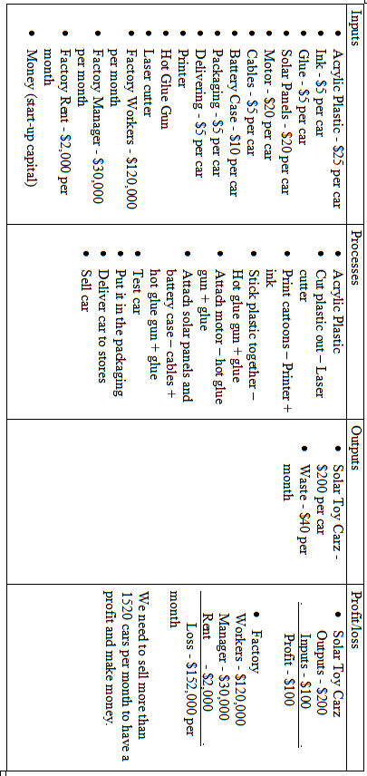

The Financial Plan

6a Sources of Finance Required
To start up my business, I will need $500,000 and here is how I am going to use this money.

Number | What the money is used for? | The Cost | For How Long?
1 | Equipment to build cars (laser cutter, glue gun) | $5,000 | 1-2 years
2 | Materials for cars | $3,000 | 2 months
3 | Factory rent | $4,000 | 2 months
4 | Salary | $410,000 | 2 months
5 | Advertisement | $8,000 | 2 months
 | Total | $430,000

The reason most of the start-up cash will be used up in 2 months is because we expect to have a loss for the first two months, but as more shops start to sell our product, more people will buy it and we will slowly move from a loss to a profit and the company is able to sustain itself without any outside help.

6b Financial Information

Cash Flow Forecast

Month | Sales | Monthly cost | Monthly cash flow | Net cash flow
1 | $160,000 | $220,000 | -$60,000 | -$60,000
2 | $210,000 | $220,000 | -$10,000 | -$70,000
3 | $230,000 | $230,000 | $0 | -$70,000
4 | $230,000 | $220,000 | $10,000 | -$60,000
5 | $300,000 | $270,000 | $30,000 | -$30,000
6 | $275,000 | $220,000 | $55,000 | $25,000
7 | $300,000 | $230,000 | $70,000 | $95,000
8 | $400,000 | $300,000 | $100,000 | $195,000
9 | $370,000 | $300,000 | $70,000 | $265,000
10 | $410,000 | $310,000 | $100,000 | $365,000
11 | $550,000 | $430,000 | $120,000 | $485,000
12 | $550,000 | $430,000 | $120,000 | $605,000

The Estimated Costs for the First Month of the Company
(to show how I calculated the numbers)
Salary $205,000/ month (10 employees)
Factory rent $2,000/ month
Robots $500,000 to be used for 5 years = $100,000/year
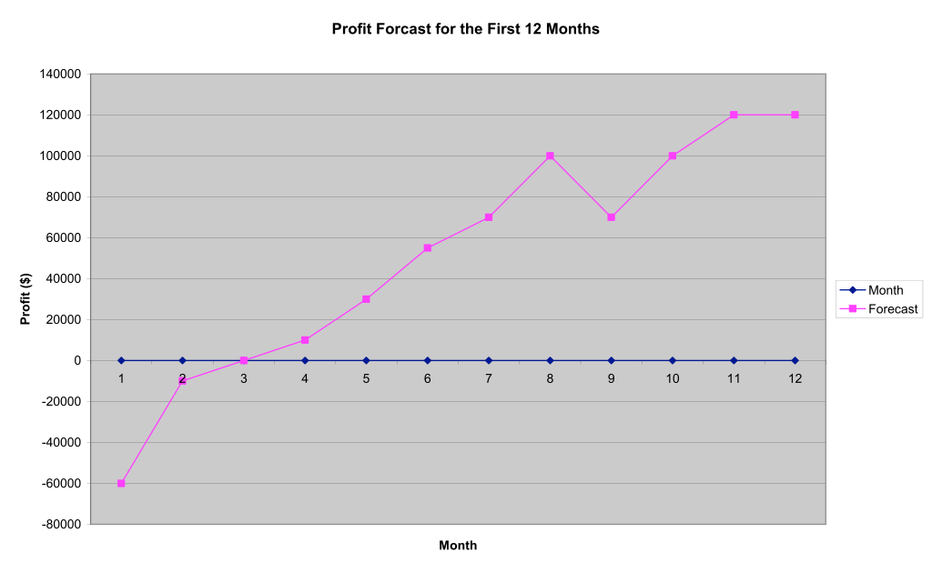
Advertisement $10,000/month (This will change every month)
Electricity $5,000/ month (This will change every month)

Total $220,166/ month (This is an approximate number, the actual number will change depending on sales)

Here is the profit forecast for the first 12 months:

For the money that we are going to make, I predict that we will have a loss in the first two months. This is because our company and cars would not be that well known and not many people will buy it. However, I expect to make a small profit by the third month, because we will sell the cars that were not sold in the previous months and because I expect to have more cars sold in shops by then. From then on, I expect to make a steady profit and by the end of the year I expect have earned around $605,000 from my company.

Here is the profit forecast for the first 5 years of our company:
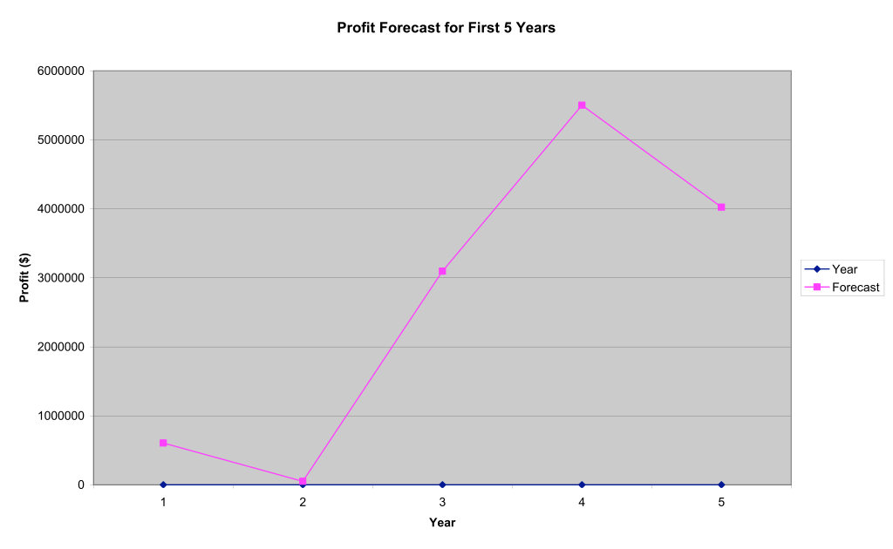
As you can see, we will make a profit every year for the first 5 years. This is because I think that our car is a really good product. As you can see, we will make a small profit for the first 2 years, but our sales will soar by the 3rd year. This is because of our goals, we expect our toys to be sold at Toys’R’us by 2013, the third year. Toys’R’us is one of the biggest toy shops in the world and having my car sold in Toys’R’us would be a really good thing for our company, as more people will see our product and buy it too. However, if we do not achieve our goal of getting our toys sold in Toys’R’us, then I think that the whole graph will have to change a lot.

